**Business Questions Template**

**1) What is the name of the stylist(s) that worked on the customer with the first name Starr**

SELECT s.sF_Name, s.sL_Name  
FROM Stylist s, Customer c, Appointment a  
WHERE a.StylistID = s.StylistID AND a.CustomerID = c.CustomerID AND c.cF_Name = 'Starr';  
2)

SELECT c.customerid, c.cF_name, c.cL_Name, SUM(s.Amount) as TotalAmount  
FROM Service s, Invoice i, Customer c  
WHERE i.CustomerID = c.CustomerID AND s.InvoiceNo = i.InvoiceNo  
GROUP BY c.CustomerID;

1) /* The manager wants to know which purchases are greater than $100,000 or less than $2,000, ordered by amount from highest to lowest. */

select amount from purchase where amount >100000 or amount <2000 order by amount desc;

2) /*Someone interested in investing in the salon is curious of the details of the profit of products, including the stylists name and average product price?*/

Select (p.price-pu.p....

/* List all details of car sales, including salesperson’s name and the gross profit (selling price minus cost price). (Hint: What special consideration do you have to deal with in this example? Specifically, how to handle column name with space?) */

select c.*, p.`person first`, p.`person last`, c.carsell-c.carcost as grossprofit from car c, person p

where c.personid = p.personid;

3) /* How many cars were sold by Sheila O'Hara? (Hint: how do you handle a column name with space?)*/

/*How many customers does ____ have total?*/

select count(carsell), p.`person first`, p.`person last` from car c, person p where c.personid='21' and p.personid='21';

/* Which shipped orders have a value greater than $5,000?*/

4) /* Which products are costing the business the most money? We want to know which products have a value greater than $5,000? */

Which stylist provide the company with the most revenue? We want to know which services have a value greater $150?

select od.ordernumber from orders o, orderdetails od where o.ordernumber=od.ordernumber group by o.ordernumber having sum(priceeach*od.quantityordered)>5000;

5) /* What products have a value greater than _____?*/

/*W hich shipped orders have a value greater than $5,000?*/

select od.ordernumber, o.status from orders o, orderdetails od where od.ordernumber=o.ordernumber and status ='Shipped' group by o.ordernumber having sum(od.priceeach*od.quantityordered)>5000;

6)/* Mrs. Czadla’s called the office to ask about the whereabouts of her husband. Her husband, Titos, claims that he had an appointment at 8pm on Sept 23, 2020. He also claims that he has had over 5 appointments from our stylist. Please check to make sure that he did receive a haircut at 8pm on Sept 23,2020. Also, count the number of appointments he has had with us.

select c.cf_name, c.cl_name, a.Date_Time, count(a.AppointmentID)

from customer c, appointment a

where c.customerid=a.customerid and c.cf_name ='Titos'

order by a.date_time desc;

7)/* List the names of the stylists who generates the highest gross profit for the company for each location.

/* List those names of products sold at less than 85% of the MSRP (MSRP*0.85).*/

select distinct p.productname from products p, orders o, orderdetails od where p.productcode=od.productcode and o.ordernumber= od.ordernumber and od.priceeach <(p.msrp*.85);

List the stylist in baton rouge that generated the most revenue for the year 2020. List

8)/* List the products ordered on a Monday. Do not list duplicates. Hint: see https://dev.mysql.com/doc/refman/5.7/en/date-and-time-functions.html for date-related functions.*/

select distinct o.orderdate, p.productname, dayofweek(o.orderdate) as Dayofweek from products p, orders o, orderdetails od where od.productCode=p.productCode and o.orderNumber=od.ordernumber and dayofweek(o.orderdate)=2;

9)/* List all customers whose data of state is missing. */

/*List all customers whose data of city is missing. */

select * from customers where state is null;

10)/* List all customers that belong to stylist named ‘%___% ‘ that is located IN “70769” zip code. */

SELECT *

From stylist

where sF_Name like '%Kat%' and sCity="New Orleans";

NULL:

Sub-Query:

11. Report the products that have not been sold

SELECT p.productCode, p.productName

FROM products p

WHERE p.productCode Not IN

(SELECT DISTINCT(o.productCode)

FROM orderdetails o);

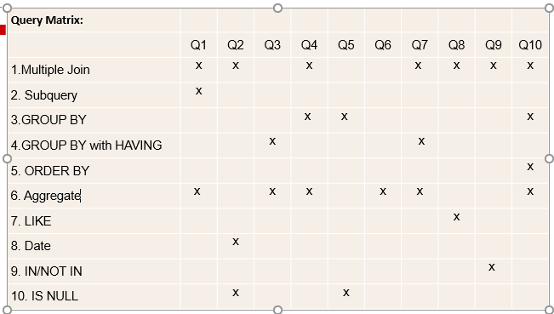

Possible questions: